User Manual
For:
Heroscape Army
Builder
Version 0.1.1

Table of Contents
About 3
Running the program 4
Windows 4
Heroscape Army Builder 5
Card Viewer 6
Reading the card 6
Synergies 7
Load 7
Creating a New Unit 8
Deleting a Unit 8
Setting all quantities to zero 8
Editing a Unit 8
Abilities 9
Copy Database 10
Appendix A 11

About
Heroscape Army Builder (HAB) is designed to aid in managing the units that one has and allow for better creation of armies. This version, 0.1.1 has limited functionality due to still being in development. This version was developed using Python 3.9.4, and as such the user will need that version, or a newer version, of python.
This version of HAB currently is only able to run the Card Viewer (described on page 6), and Copy Database (described on page 11), other functionality will be added in future updates.
HAB is developed by Benjamin Jones, or Jazack on heroscapers.com. Any inquiries, bugs, or other items about HAB, ought to be brought to Benjamin Jones via either a message through heroscapers.com or an email to flenogo@gmail.com, with “Heroscape Army Builder” in the subject line.
I hope that you enjoy the program.

Running the program
First, if you do not have Python 3.9.4, or a later version of Python, you need to update python. Here are the links to the download links for python:
- Windows: https://www.python.org/downloads/
- Linux/Unix: https://www.python.org/downloads/source/
- Mac OS X: https://www.python.org/downloads/mac-osx/
Select the latest release and follow the instructions for your specified OS.
Next you will need to download the files, which are stored via github. Download the files and place them where you desire to store them.
The file that will launch the program is RUNME.py, if double clicking on that does not work, you can start this program via the command line, and as such you will need to go through that to run it. Unfortunately, I do not know how to do this process with Mac, as such, if anyone knows how to do this, and is willing to send me the instructions so that I can add them to this document, that would be appreciated.
There are two starting databases, units.db, and Official Units.db. units.db has all of the official units, as well as some of the vc units, while Official Units.db contains only the official units.

Windows
For windows, you can open you will need to open command line, this can be done via pressing the windows+R, and then typing ‘cmd” and pressing Enter. The command line will then appear.
Next, you will need to change directories to the location where you are storing the files. To do this, type “cd “ followed by the location that they are stored (if you are unsure of the full address, you can copy the address from the file location by opening it up in file explorer, selecting the location, and copying it, and then pasting it in the command line).
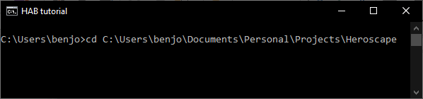Figure 1: what the above line looks like on my command line
After going to the directory, you will type in “RUNME.py” and press enter. The program will then start.

Heroscape Army Builder
The Heroscape Army Builder starts with a couple options, the default for the database is the units.db, this can be changed via clicking the box and picking a new database to use. The initial options are units.db and NEW. NEW will allow you to name your own database, while units.db is a standard database that has many of the original and cv characters.
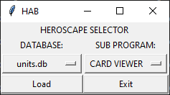Figure 2: the main menu
The other item is the SUB PROGRAM, this is what allows you to choose which sub program you wish to run, whether it’s the card viewer, database copier, or one of the other army managers that is currently in development (NOTE: currently only the card viewer and database copier are available).
Once the items are chosen, you click on the Load button, and it will load the sub program with the chosen database.

Card Viewer
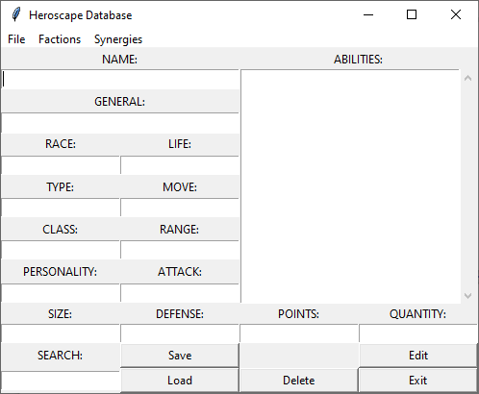Figure 3: The entry screen for the Card Viewer

The card viewer initializes at an empty card. Here you can manage the units in your database, and it will show you how each unit interacts with other units.

Reading the card
The card contains various fields from, each of which corresponds to a field found on any unit card. This contains, the Name of the unit in the NAME field, the Arch Kyrie that the unit follows in the GENERAL field, the race of the creature in the RACE field, and so on and so forth. The QUANTITY field is the amount of that specific unit you have. This will be used in later renditions of the program to build armies using your available units.
All of the card elements are locked from being edited, save for the quantity section. The editing process will be explained lower.
Each Arch Kyrie also has their own color to aid in readability. Also, if the unit has a special ability that affects a specific group of units, that will appear on the side with a link to each unit so as to be able to understand what that unit does.
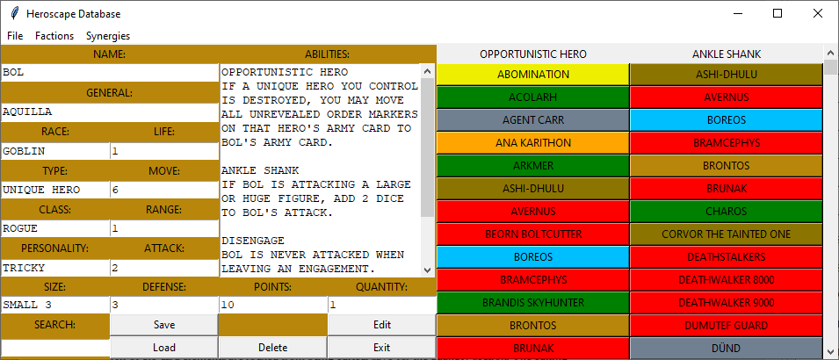Figure 4: The card for Bol
The card for Bol is shown in Figure 4. As can be seen, his Opportunist Hero ability is able to work on many units, all gathered in alphabetical order, and then the section over is his Ankle Shank ability with all of those units in alphabetical order. Clicking on any of their names will instantly direct you to their respective cards.
To see what abilities other units have that can affect a given unit, go to the Synergies drop down menu, and it will give three options, these being “Allies”, “Enemies”, and “Neutral”. Each of these three menus will show units whose abilities will only work on the selected unit if they are an ally, enemy, or if it will affect them regardless of status.

Synergies
All of the synergies that a given unit has will be displayed in two locations. The first location is to the right of the unit information. The synergies, if any, that are displayed here are ones where the unit directly affects them in one way or another, such as in Figure 2, where Bol’s synergies can be seen on the right of his figure, both the ability that comes into play with allies, and the ability that comes into play with enemies.
The other location can be found via the synergies menu at the top of the screen. This section of synergies are ones where a different unit can affect the current unit. It is divided up into three sections, these being synergies that come from being allied with the unit, synergies that just occur, and synergies that come from being an opponent of the unit.

Load
To load a unit, you can either type in the units complete name in the search bar and then press load, or you can click on Factions → the faction the unit is in → the unit name that is desired to be loaded.
It’s as simple as that.

Creating a New Unit
Creating a new unit can be done in one of two ways. These being either going through the drop-down menu, File → New, or by editing an already existing unit and changing their name to a new name.
NOTE: The program saves each unit based on their name, and so if an existing unit already has the same name, the new version will be saved on top of the previous version.

Deleting a Unit
In order to delete a unit, you must first go to that unit’s card, and then press the Delete button. The unit will then be deleted.
This will not be reflected until you leave the said unit’s card, at which point it will become permanent.

Setting all quantities to zero
If, for whatever reason, you desire to set all quantities to zero, the button to do so can be found at File → Empty All. Here you will be presented with an option to set all to zero, or leave it be. If you choose to set to zero, it will not take place until after you close the Card Viewer, and then it will take a minute or two to properly go through and update each card.
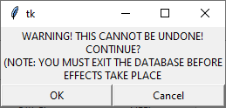Figure 5: Message asking if you are sure about setting all quantities to zero
If you by mistake decided to click the OK button on Figure 5, you are able to go through the same steps (File → Empty All) and click Cancel, that will stop it from emptying.

Editing a Unit
To edit a unit, you press the Edit button, and every field will become editable, and you will notice that in the Abilities section there will be some extra items. In Figure 3 you can note that there are various elements such as <POWER> or <CLA>, these will be explained in the section Abilities.
You will make any changes that are desired to for the unit, and then press Save, either via the button, or File → Save. Either way will save the unit.
After saving, everything will automatically be made into uppercase for your convenience.
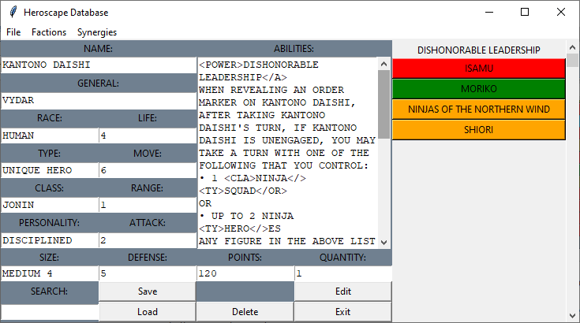Figure 6: Kantono Daishi

Abilities
The abilities section is perhaps one of the most complex sections, as there are many tags to be aware of. A complete index of each tag, and what it is used for, can be found in Appendix A. There are two types of tags, opening and closing tags. Opening tags with follow a format of <tag>, and closing tags with have an extra “/”, so that </tag> will be a closing tag. Each opening tag must be coupled with a closing tag.
To start, you will place a <POWER> tag before the name of the ability, and at the end of the ability you will place one of the following end tags, </A>, </N>, </E>, these signifying that they affect allies, that they affect both allies and enemies equally (or not at all, such as with flying), or that they affect enemies, each respectively.
For example, in Figure 6, Dishonorable Leadership, which affects allies, is encapsulated by <POWER> … </A>, meaning that it is an ability that affects allies.
Then, you will find all keywords, the words that describe who is affected (ignoring all words that show who controls the unit, as that can vary from game to game, and so is marked by the end tag with the power), and encapsulate them with a tag. If there are multiple descriptors that use the same tag, you will use an </OR> end tag on each of those items, save for the last one. Again, referring back to Figure 6, Dishonorable Leadership affects squads and heroes, and as “SQUAD” comes before “HEROES”, it is encapsulated thusly: <TY>SQUAD</OR>, and “HEROES” is encapsulated as such: <TY>HERO</>ES (heroes is a special case, where the end tag precedes the end “ES”, all other keywords will have an end tag at the end)

Copy Database
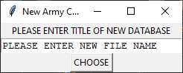Figure 7: Input screen for a new database
To copy a database, you first will select the COPY DATABASE from the sub program menu, as well as the database that you desire to copy, and then click “Load”. This will bring you to a new window, which is shown in Figure 7, here you will enter the name for the new database that will be created.
After you have entered a name, click on “CHOOSE” to select the name, and the new database will be created and you will be brought back to the main menu.

Appendix A
A list of tags for editing abilities (The tag defines the units that can be affected by it):
</> - this tag is a generic closing tag. It will close whichever tag proceeds it.
</A> - This tag is used to signify the end of an abilities name, and that the power directly affects allies of the unit.
<ABILITIES> - This tag is used to signify that an ability keyword is about to be used. Such as Su-Bak-Na’s Hive Supremacy, which looks for abilities with the roll keyword.
<ATTACK> - This tag is used to signify a number of attack dice. This tag only exists so that the abilities can be edited in any way, no official character (that I’m, aware of) would use this tag,
<CLA> - This tag is used to signify that a class keyword is about to be used, such as Ninja or Warrior.
<DEFENSE> - This tag is used to signify that a defense keyword is about to be used. This tag only exists so that the abilities can be edited in any way, no official character (that I’m, aware of) would use this tag,
</E> - This tag is used to signify the end of an abilities name, and that the power directly affects enemies of the unit.
<GENERAL> - This tag is used to signify that a General keyword is about to be used, such as Jandar or Ullar.
<GRAN> - look up <RAN>
<HID> - This tag is used to hide a section from standard view. Either for notes or editing purposes, such as with Kelda to allow for Healing Touch to work properly.
This tag is the only tag that uses itself as an end tag. Alternates are: <HIDDEN>
<LIFE> - This tag is used to signify that a life keyword is going to be used. Look at Kelda in edit for an example
<LRAN> - Look up <RAN>
<MOVE> - This tag is used to signify how much movement the affected unit has. This tag only exists so that the abilities can be edited in any way, no official character (that I’m, aware of) would use this tag,
</N> - This tag has two uses, one with ability heads (being coupled with <POWER>, and one for keywords).
The <POWER> usage is used to signify the end of an abilities name, and that the power can be used to affect both allies and enemies, and so is therefore a neutral ability, such as Brontos’ Abduct ability which can be used on both allies and enemies. Passive abilities such as flying can also use this tag. Technically </> can be used in place of this tag, but that is bad practice.
The keyword usage is used to signify that something is not allowed for the ability, such as Kee-Mo-Shi’s Toxic Skin ability, which does not affect soulborgs.
<NAME> - This tag is used to specify a name, such as the Rechet’s of Bogdan’s ability Iskra’s Summoning.
</OR> - This tag is used to signify that the previous tag has ended, and that another tag of the same type will occur and that either of the two keywords can be usable, such as with Kanto Katsuro Kanto Katsuro’s Command being able to affect squads or heroes.
<PERSONALITY> - This tag is used to signify that a personality keyword is about to be used, such as the 4th Massachusetts Line Valiant Army Defense Bonus.
<POINTS> - This tag is used to signify that a points keyword is about to be used. This tag only exists so that the abilities can be edited in any way, no official character (that I’m, aware of) would use this tag,
<POW> - This tag is used to signify that a power keyword is about to be used, such as Venoc Warlord’s Frenzy Enhancement, which aids any power with the Frenzy keyword.
<POWER> - This tag is used to identify abilities, it will directly proceed an abilities name, it’ll generally be coupled with either </A>, </N>, or </E>
<RACE> - This is used to signify that a race keyword is about to be used, such as Orc, or Elf.
<RAN> - This tag, couple with <GRAN> and <LRAN> are used for range keywords.
<RAN> is used for if a specific range is required, such as Finn the Viking Champion requiring a range of 1 for Attack Aura 1.
<GRAN> is used for if a range greater than or equal to a specific range is given, such as Laglor’s Vydar’s Range Enhancement Aura.
<LRAN> is used for if a range less than or equal to a specific range is given.
<SIZE> - This tag signifies that a size keyword is about to be used.
</T> - This tag signifies the end of one group of classifications for an ability and where another will begin, such as in the Greenscale Warriors’ Loyalty to the Lizard King ability, where either a unique lizardfolk hero, or a large or huge unique dragon hero, is allowed. The two categories are quite discrete and so a stronger or end tag is needed, or a True or statement, if you will.
<TY> - This tag signifies that a Type keyword is about to be used, such as Unique, Uncommon, Common, Hero, or Squad. Note, if the keyword is “HEROES”, place the closing tag between the “O” and “E”, such as “<TY>HERO</>ES”.
<QUANTITY> - This tag signifies a quantity keyword. This would be the quantity that you possess. This tag only exists so that the abilities can be edited in any way, no official character (that I’m, aware of) would use this tag,

